Day 3

23/5/2025

https://docs.google.com/document/d/1-ZyINjFpkTJrgU7N9fVI486ftXK871m_bkRzzI-Enzc/edit?tab=t.0

1.What is cloud and the advantages of cloud.?

Cloud computing delivers on-demand computing services – over the internet. Instead of owening physical hardware you access resources froma 3rd party provider. You pay only for the what you use, similar to a utility of a service.

Advantages of cloud:

* Cost Saving because you reduce upfort hardware costs and pay only for consumed resources.
* Scalable as it is easy to expand or shrink resources to match changing demands.
* Global Access so that you can assess your data and application from anywhere, anythime..
* Reliable as it benfits from robust infrastructure and built-in disaster recover.
* Increased Productivity as it focuses on innovation, not infrastructure management.

BUILD HELLO WORLD: 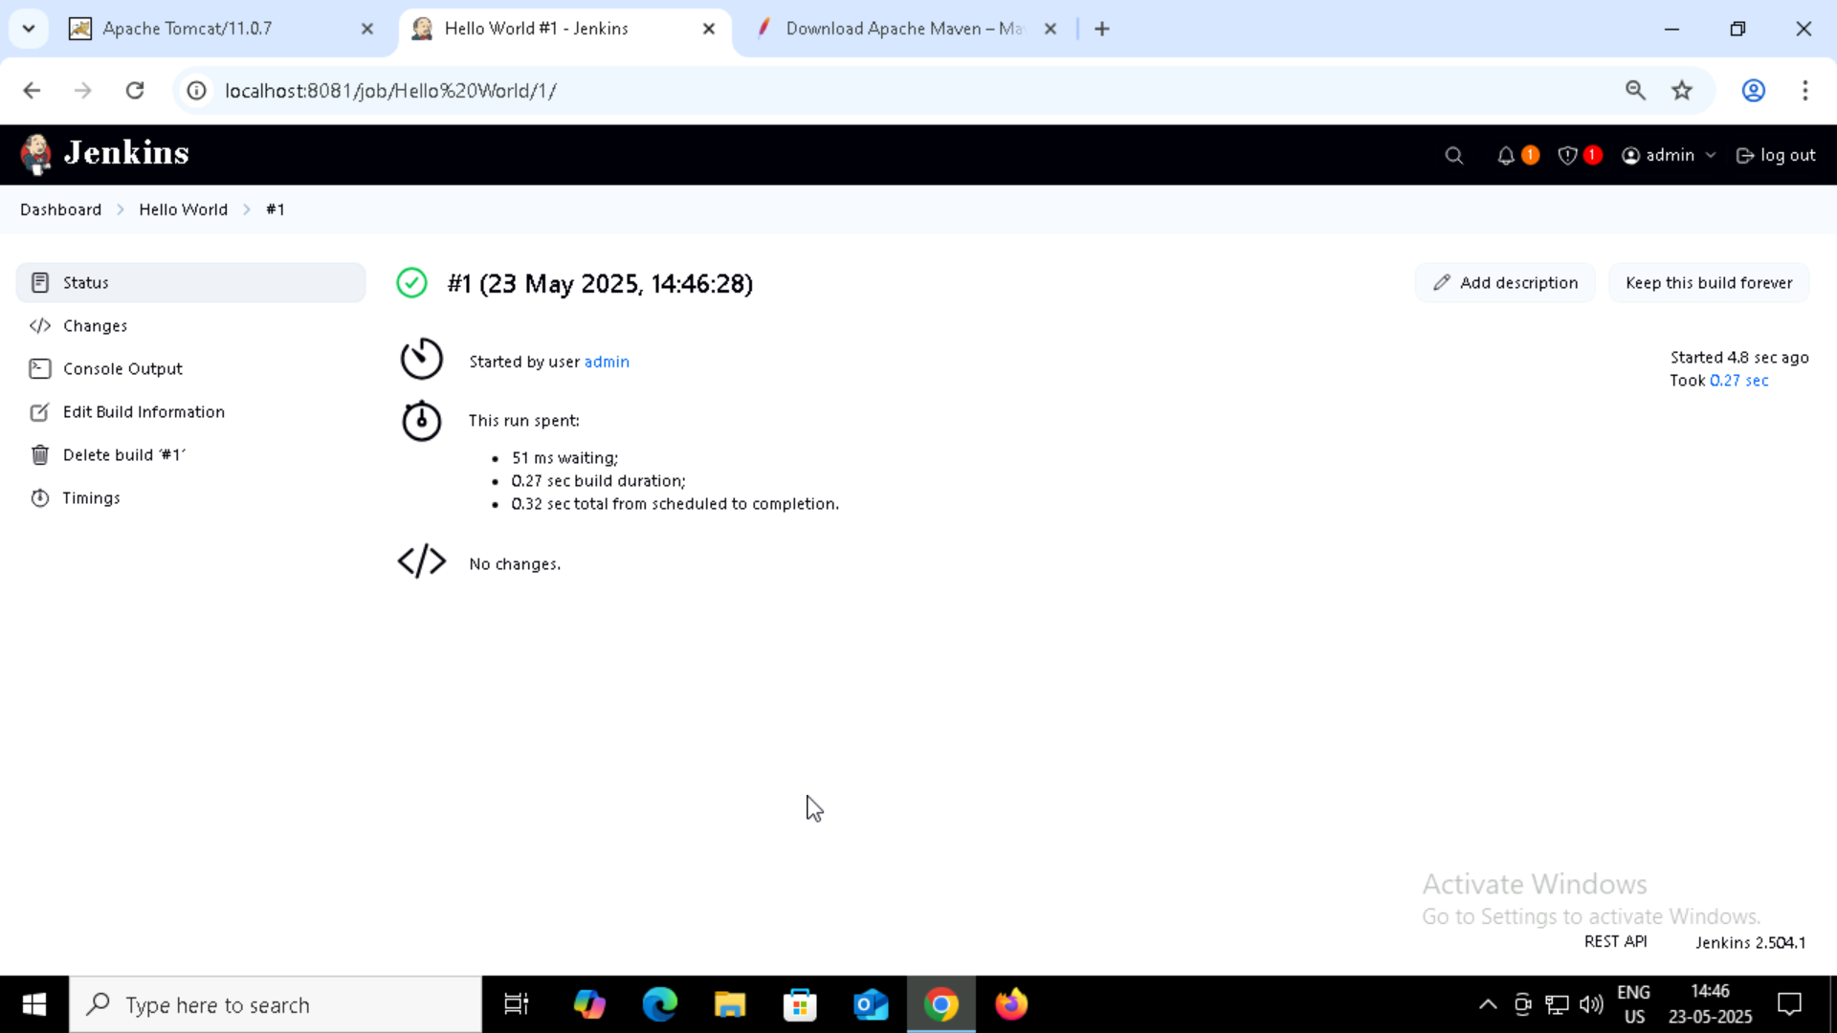

LINKEDLIST TESTING: 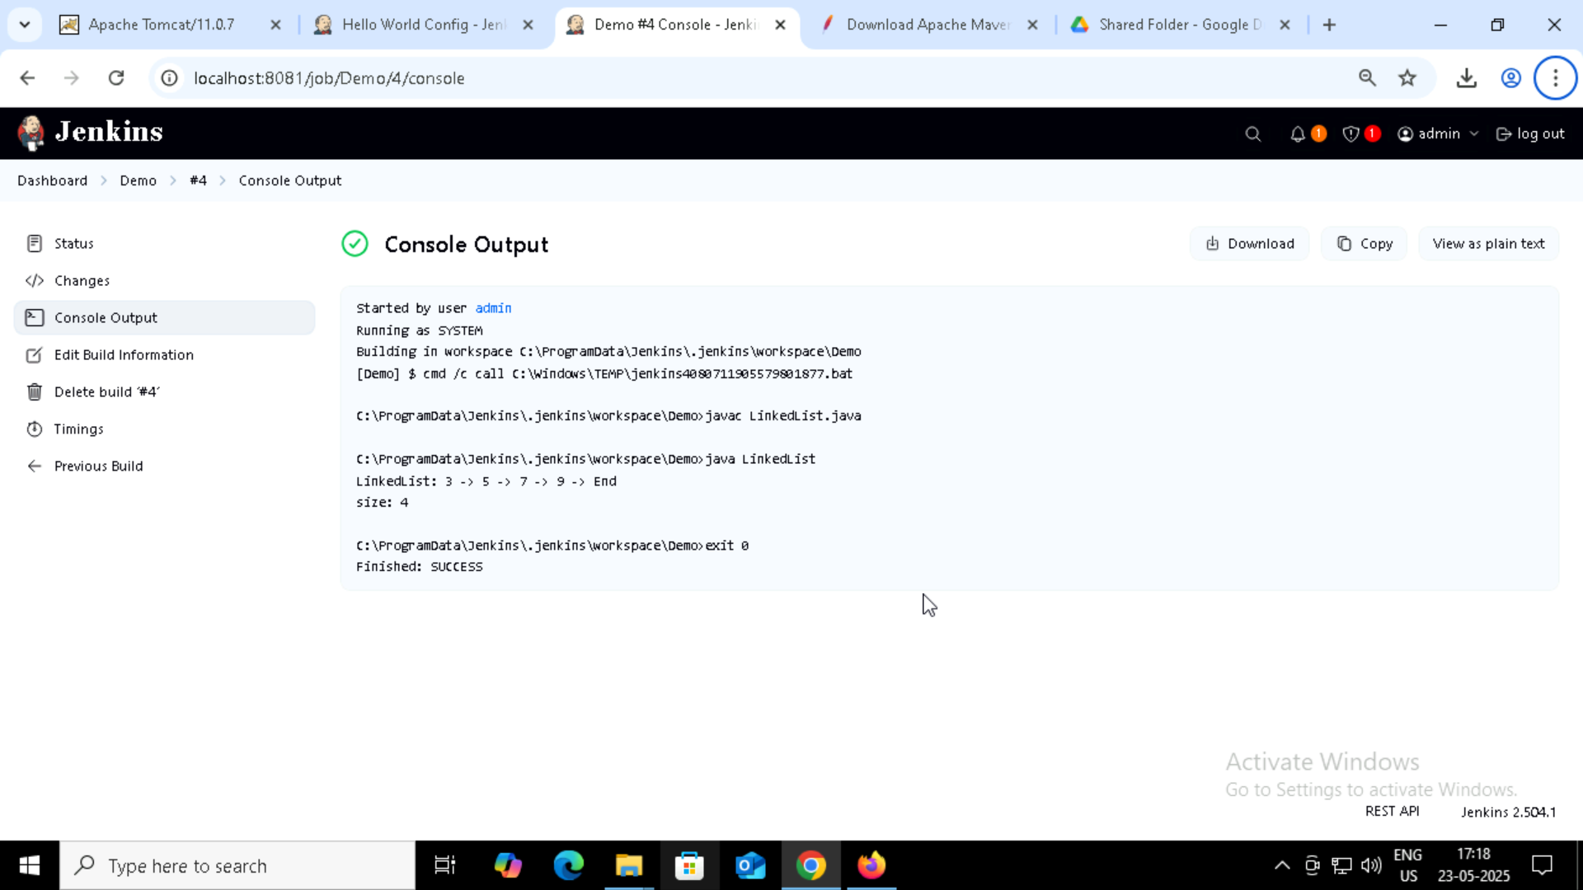

Brought out the error.

Checked how the error reflects.

Tried to bring out the output.